**Spring 2017**

**ESI 5359**

**Industrial Financial Decisions**

**Yezehao Huai (5965823)**

**Chapter 6 Homework**

**2. Cordillera Carson Company has the following balance sheet and income statement for 20X2 (in thousands):**

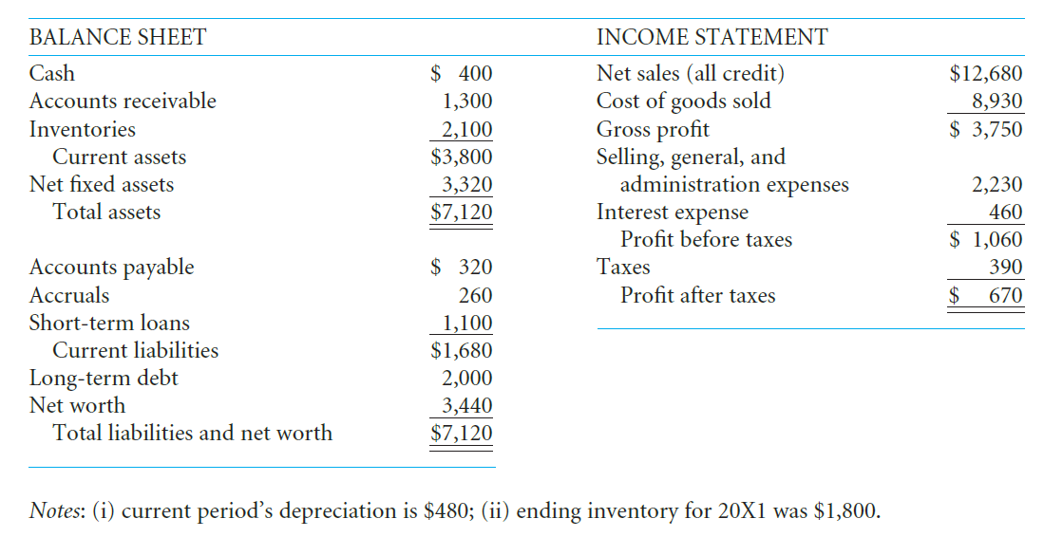 **On the basis of this information, compute (a) the current ratio, (b) the acid-test ratio, (c) the average collection period, (d) the inventory turnover ratio, (e) the debt-to-net-worth ratio, (f) the long-term debt-to-total-capitalization ratio, (g) the gross profit margin, (h) the net profit margin, and (i) the return on equity.**

1. current ratio=$3,800/$1,680=2.26
2. acid-test ratio=($3,800-$2,100)/$1,680=1.01
3. average collection period=365/RT=365/($12,680/$1,300)=37.42 days
4. inventory turnover ratio=$8,930/$2,100=4.25
5. debt-to-net-worth ratio= ($1,680+$2,000)/$3,440=1.07
6. long-debt-to-total-capitalization ratio=$2,000/($2,000+$3,440)=0.37
7. gross profit margin=$3,750/$12,680=0.2957
8. net profit margin= $390/$12,680=0.0528
9. return on equity=$670/$3,440=0.1948

**4. The following information is available on the Vanier Corporation:**

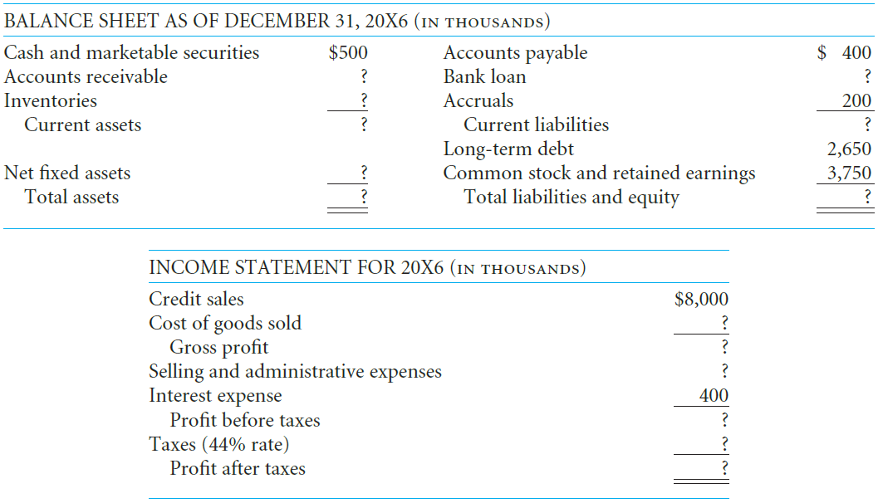

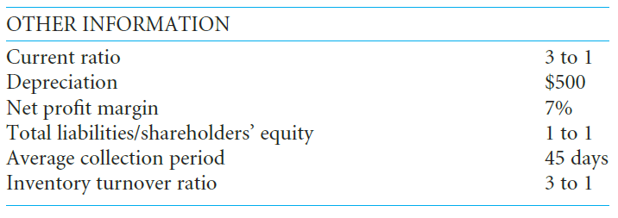

**Assuming that sales and production are steady throughout a 360-day year, complete the balance sheet and income statement for Vanier Corporation.**

1. Accounts receivable=$8000/(365/45)=$1,000
2. Total liabilities= shareholder’s equity=$3,750
3. Total liabilities and equity=$3,750*2=$7,500=Total assets
4. Current liabilities=$3,750-$2,650=$1,100
5. Current assets=$1,100*3=$3,300
6. Inventories=$3,300-$500-$1000=$1,800
7. Net fixed assets=$7,500-$3,300=$4,200
8. Bank loan=$1,100-$200-$400=$500
9. Cost of goods sold=$1,800*3=$5,400
10. Gross profit= $8,000-$5,400=$2,600
11. Profit after taxes=$8,000*7%=$560
12. Profit before taxes=$560/(1-44%)=$1,000
13. Selling and administrative expenses=$2,600-$400-$1,000=$1,200

**8. Tic-Tac Homes has had the following balance sheet statements the past four years (in thousands):**

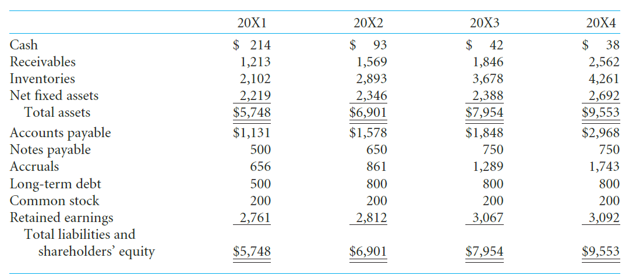

**Using index analysis, what are the major problems in the company’s financial condition?**

|  |  |  |  |  |
| --- | --- | --- | --- | --- |
| INDEXD% | 20X1 | 20X2 | 20X3 | 20X4 |
| Cash | 100.00 | 43.46 | 19.63 | 17.76 |
| Receivables | 100.00 | 129.35 | 152.18 | 211.21 |
| Inventories | 100.00 | 137.63 | 174.98 | 202.71 |
| Net fixed assets | 100.00 | 105.72 | 107.62 | 121.32 |
| Total assets | 100.00 | 120.06 | 138.38 | 166.20 |
| Account payable | 100.00 | 139.52 | 163.40 | 262.42 |
| Notes payable | 100.00 | 130.00 | 150.00 | 150.00 |
| Accruals | 100.00 | 131.25 | 196.49 | 265.70 |
| Long-term debt | 100.00 | 160.00 | 160.00 | 160.00 |
| Common stock | 100.00 | 100.00 | 100.00 | 100.00 |
| Retained earnings | 100.00 | 101.85 | 111.08 | 111.99 |
| Total liabilities and shareholder’s equity | 100.00 | 120.06 | 138.38 | 166.20 |

By using the index analysis, we can find that the receivables, inventories and net fixed assets increased a lot from 20X1 to 20X4, but just increased a little from 20X1 to 20X3. The next problem is Notes payable and Accruals increased too much. In addition, the company’s long-term debt hasn’t finish since 20X2. The last problem is retained earnings grew very slow.